***Cyber Security Assignment| Day 4***

*Name: - Amandeep Singh*

*Registered Email: -* [*amandeepsingh13.2000@gmail.com*](mailto:amandeepsingh13.2000@gmail.com)

Q1. To find out the Mail Servers of the following Domains:

1. Ibm.com
2. Wipro.com

Answer

1. Fire up kali and login into it and open the terminal.
2. The user can be a administrator using command (sudo su –)and typing in password otherwise the command nslookup works otherwise as well.
3. Type the command nslookup and press enter.
4. Use the command set type=mx and press enter.
5. Type in the domain and press enter.

**Ibm.com**

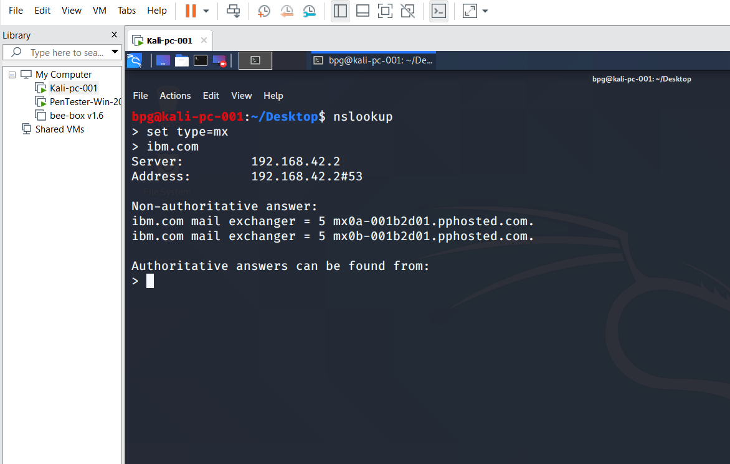

**Wipro.com**

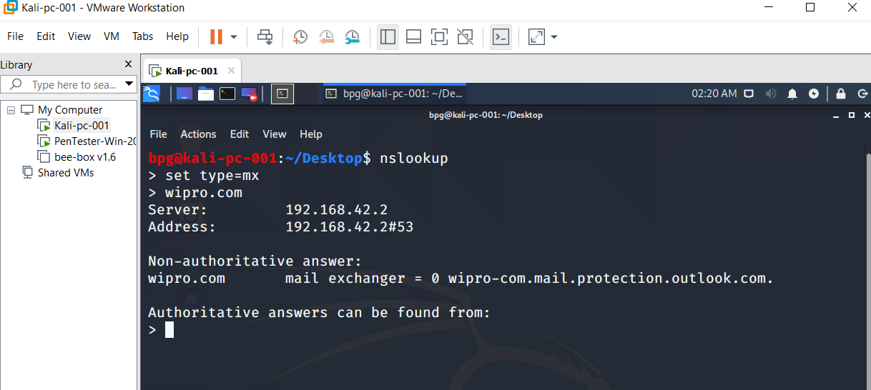

Q2. Locations where these email servers are hosted.

Answer. Continuation to Answer 1, Open any ip location finder on search engine and copy the mail exchanger and click find. This will give the location of the email servers of the following domains.

I opened location finder- <https://tools.keycdn.com/geo> and used it to find the location.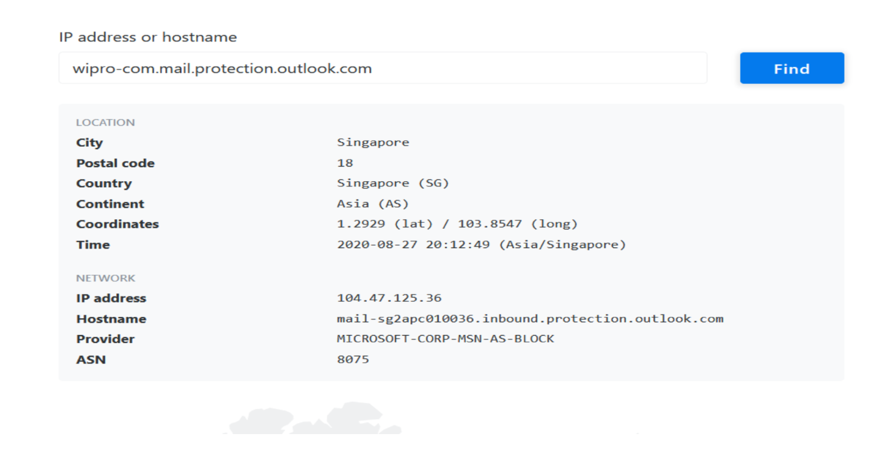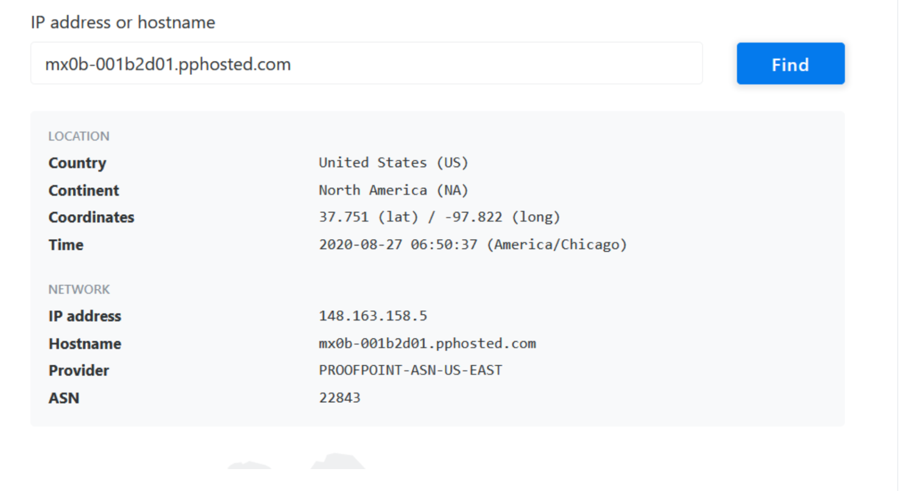

Q3. Scan and find out port numbers open 203.163.246.23

Answer.

1. Fire up kali and login into it and open the terminal.
2. The user have to be a administrator using command (sudo su –)and typing in password and pressing enter3
3. Type in the command nmap and then the ip address

(A)nmap 203.163.246.23 and press enter.

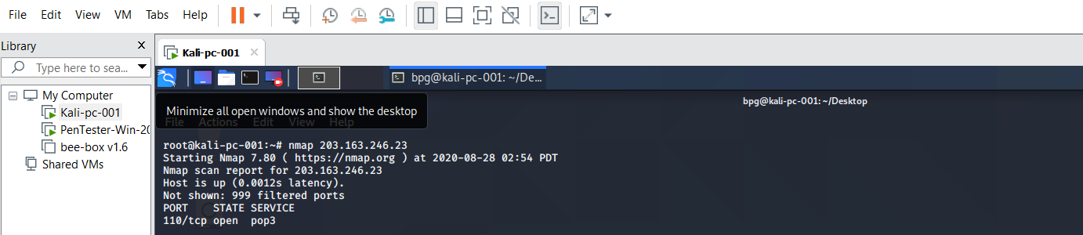

(B)nmap –Pn –Ss 203.163.246.23 and press enter.

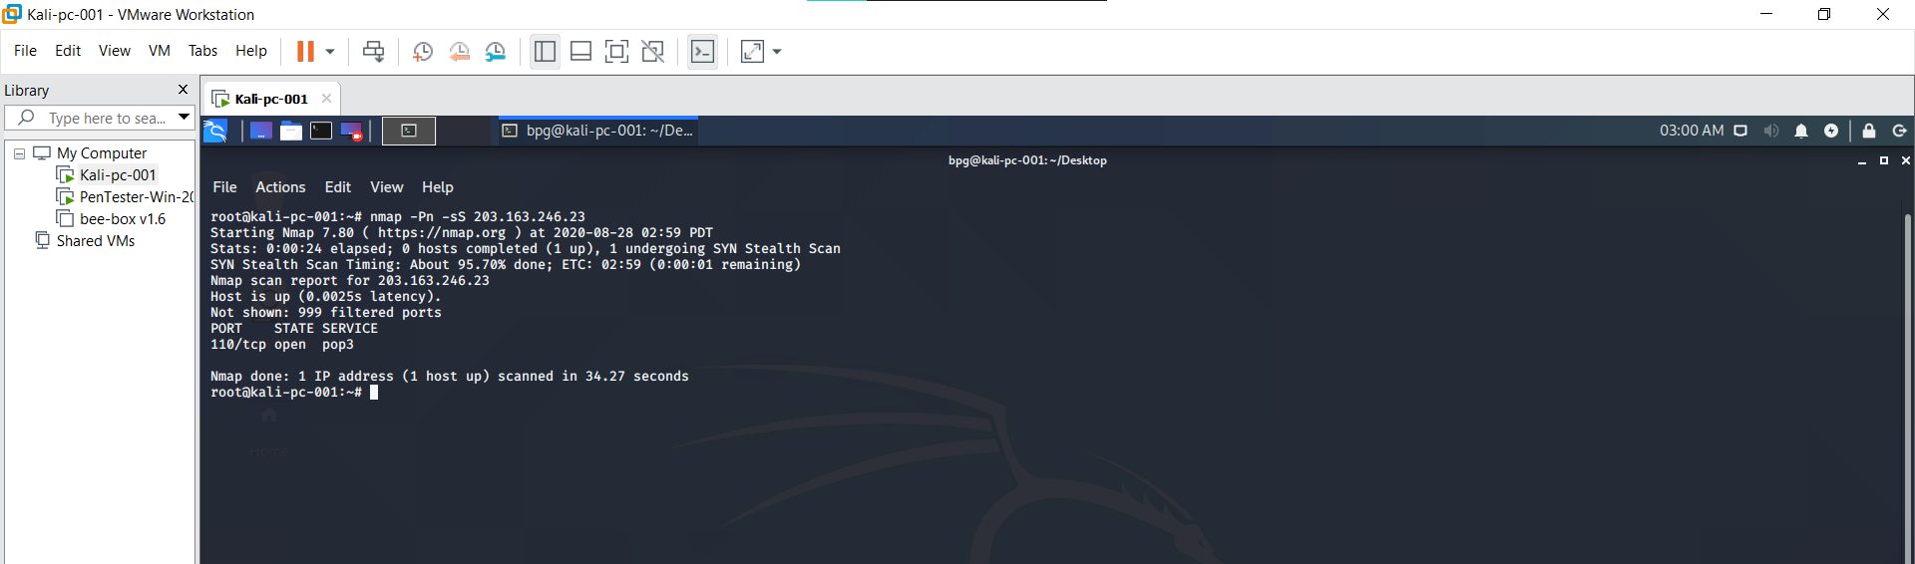

Q4. Install Nessus in a VM and scan your Laptop for CVE.

Answer.

1. Open Pentester VM and log into it.
2. Install Nessus in it and open in it in a suitable browser.
3. Enter your Ipv4 address of your machine in the popup box and start scanning .
4. Wait for the scan to be finished.
5. After the scan is over we can see the reports. Check the Vulnerabilities to view the reports.

